Wouldn’t it be lovely

Verse 1:
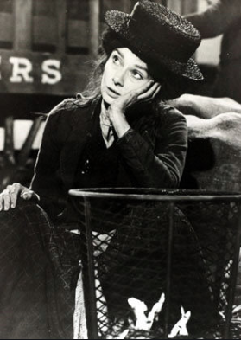
All I want is a room somewhere, far away from the cold night air.
With one enormous chair. Oh, wouldn't it be loverly? (loverly)

Verse 2:
Lots of chocolate for me to eat. Lots of coal making lots of heat.
Warm face warm hands warm feet. Oh, wouldn't it be loverly?

Refrain:
Oh so loverly sitting absobloomlutely still.
I would never budge till spring crept over the windowsill.

Verse 3:
Someone's head resting on my knee, warm and tender as he can be,
Who takes good care of me. Oh, wouldn't it - be loverly?

Repeat all above from start

Outro:
Loverly, loverly, loverly. Loverly

