All Around My Hat (Tina)
Chorus:
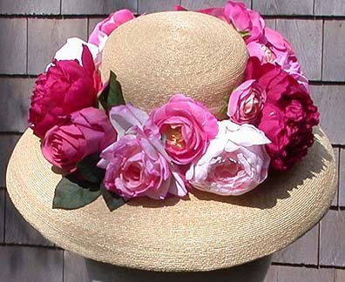
All around my hat I will wear the green willow
And all around my hat for a twelve month and a day
And if anyone should ask me the reason why I'm wearing it
It's all for my true love who's far, far away
Fare thee well cold winter and fare thee well cold frost
Nothing have I gained but my own true love I've lost
I'll sing and I'll be merry when occasion I do see
He's a false deluding young man, let him go, farewell he
The other night he brought me a fine diamond ring
But he thought to have deprived me of a far better thing
But I being careful like lovers ought to be
He's a false deluding young man, let him go, farewell he and Repeat Chorus
It's a quarter pound of reasons and a half a pound of sense
A small sprig of time and as much of prudence
You mix them all together and you will plainly see
He's a false deluding young man, let him go, farewell he and Repeat Chorus

