Kiss Me Honey Honey Kiss Me (Gina and Les)
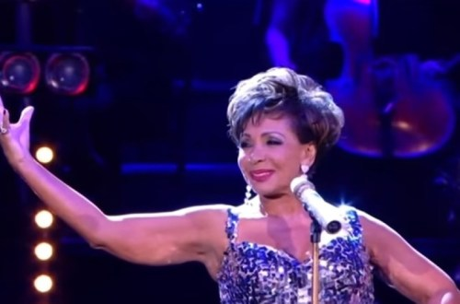
Kiss me, honey, honey, kiss me
Thrill me, honey, honey, thrill me
Don't care even if I blow my top
But, honey, honey, (AH HAH) don't stop

I'd like to play a little game with you
A little game especially made for two
If you come close then I will show you how
Closer, closer, now
Kiss me, honey, honey, kiss me
Thrill me, honey, honey, thrill me
Don't care even if I blow my top
But, honey, honey, (AH HAH) don't stop

We've never played this little game before
If you relax then you'll enjoy it more
Just settle down and let me teach you how Closer, closer, now
Kiss me, honey, honey, kiss me
Thrill me, honey, honey, thrill me
Don't care even if I blow my top
But, honey, honey, (AH HAH) don't stop

You kiss so well my lips begin to burn
And I can tell I've got a lot to learn
So hold me close and darling show me how
Closer, closer, now
Kiss me, honey, honey, kiss me
Thrill me, honey, honey, thrill me
Don't care even if I blow my top
But, honey, honey, (AH HAH) don't stop

