My Little Daffodil (Gina and Les)

My little daffodil has the sweetest smile,
Dear little daffodil won’t you stay awhile,
Come with me where moonbeams paint the sky,
And you and I might linger in the sweet by and by oh…

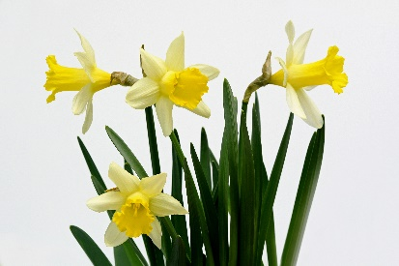
Dear little daffodil with your eyes so blue,
Oh little daffodil you’re a dream come true,
You and I will settle down in a cottage built for two,
Dear little daffodil I love you.

My little daffodil has the sweetest smile,
Dear little daffodil won’t you stay awhile,
You and I will settle down in a cottage built for two,

Dear little daffodil … Sweet little daffodil … My little daffodil …I love you.

