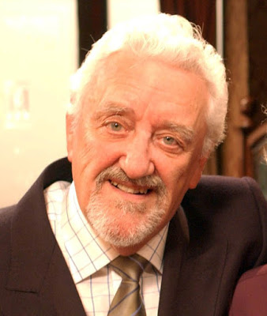
The Hole in the Ground (Ervin)
Verse 1: There I was... a - digging this 'ole,
'Ole in the ground, s' big, and sought of round, it was,
And there was I, digging it deep,
It was flat at the bottom, and the sides were steep!

Verse 2: When, along... comes... this bloke in a bowler,
Which he lifted, to scratch his head, well,
He looked down the 'ole, poor demented soul, and he said,

Posh voice bowler hats spoken: "Do you mind if I make a suggestion?”

Verse 3 posh voice bowler hats: Don't dig there! Dig it else - where!
You're digging it round, and it ought to be square,
The shape of it's wrong, it's much too long,
And you can't put a hole where a hole don't be - long!"

Link: I ask you! What a liberty, eh? 'Nearly bashed him right in the bowler!

Verse 4: Well, there was I... a - stood in m' hole,
Shovelling earth, for all that I was worth, I was,
And there was 'im, standing up there,
So grand, and official, with his nose in the air!

Verse 5: So I gave... 'im... a look, sort of side-ways,
And I leaned on m' shovel, and sighed, well,
I lit me a fag, and 'aving took a drag, I replied-

Verse 6: "I just couldn't bare... to dig it else - where,
I'm digging it round, 'cause I don't want it square,
And if you disagree, it doesn't bother me, that's the place where the 'ole's gonna be!"

Outtro: Well, there we were, dis - cussing this 'ole,
'Ole in the ground, s' big, and sought of round, it was,
(Slower:) It's not there now, the ground's all flat,
And be - neath it is the bloke in the bowl – er hat, and that's that!

