I’m a little teapot / On Mother’s Day warmup!
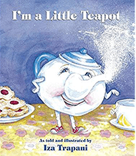
I’m a little teapot short and stout
Here’s my handle, here’s my spout
When the kettle boils, hear me shout
Tip me up and pour me out!

I’ve got something special for mother’s day
To thank you for the love you give me every day
It’s just a little heart but it says all I can say
And it’s just for you on Mother’s Day

I put my hands together, this is how I start
I curve my fingers around so they make a heart
Then I blow a little kiss and send it your way
And it’s just for you on Mother’s Day

