Day trip to Bognor, [Sheringham,] [Key=c]

CHORUS:-
Didn't we have a lovely time the day we went to Bangor
A beautiful day we had lunch on the way And all for under a pound you know
Then on the way back I cuddled with Jack And we opened a bottle of cider
Singing a few of our favourite songs as the wheels went round

Do you recall the thrill of it all as we walked a-long the sea front
Then on the sand we heard a brass band That played De Diddle De Bum Ta Ra
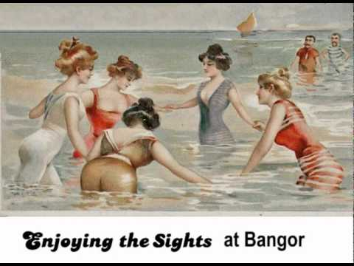
Elsie and me had some cups of tea then we took a peddler boat out Splashing away as we toured round the bay as the wheels went round
CHORUS:-

Wasn't it nice eating chocolate ice as we strolled a-round the funfair
Then we ate eels on the big Ferris wheel we sailed above the ground but then
We had to be quick because Elsie felt sick and we had to find somewhere to take her
I said to her lad "what made her feel bad" Twas the wheels went round
CHORUS:-

Elsie and me we finished our tea, and we said good-bye to the seaside
Back on the bus Flo says to us oh isn't it a shame to go
Wouldn't it be grand to have cash on demand, and to live like this for a-lways
Oh it makes me feel ill when I think of the Mill
and the wheels going round and the wheels going round
and the wheels going round and the wheels going round

