Food glorious food! :- (Key=G)
Food, glorious food, Hot sausage and mustard! While we're in the mood, Cold jelly and custard!
Peas pudding and saveloys, What next is the question?
Rich gentlemen have it, boy’s indigestion!

Food Glorious food, we’re anxious to try it
Three banquets a day, our favourite diet

Just picture a great big steak, Fried, roasted, or stewed, oh!
Food! wonderful food! marvellous food! glorious food!

Food glorious food! Don't care what it looks like
Burnt underdone crude, don't care what the cooks like
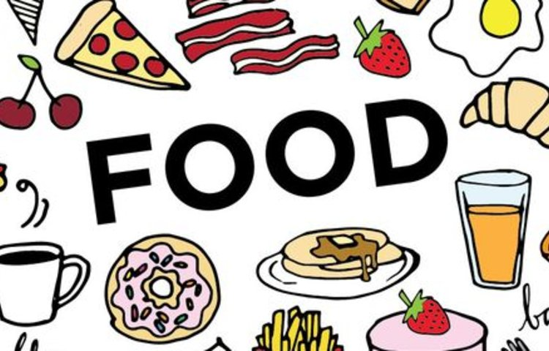
Just thinking of growing fat our senses go reeling
One moment of knowing that Full up feeling

Food glorious food. What wouldn't we give for
That extra bit more. That's all we live for

Why should we be fated to do nothing but brood on

Food! Magical food! Wonderful food! Marvellous food!
Fabulous food! Beautiful food! Glorious food!

