Imagine:- [Key=C]

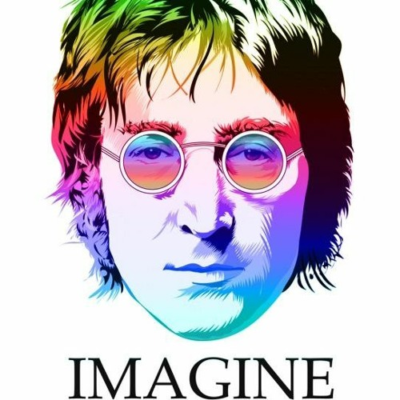
Imagine there’s no heaven It’s easy if you try
No Hell below us Above us only sky
Imagine all the people living for today

Imagine there’s no countries, It isn’t hard to do
Nothing to kill or die for no religion too
Imagine all the people living life in Peace You…………

You may say I’m a dreamer But I’m not the only one
I hope someday you’ll join us, And the world will be as one

Imagine no possessions I wonder if you can
No need for greed nor hunger A brotherhood of man
Imagine all the people Sharing all the world you………

You may say I’m a dreamer But I’m not the only one
I hope someday you’ll join us, and the world will live as one

