Jambalaya [Key=C]
Son of a gun, we'll have big fun on the bayou Good-bye Joe, me gotta go, me oh my oh Me gotta go pole the pirogue down the bayou My Yvonne, the sweetest one, me oh my oh Son of a gun, we'll have big fun on the bayou
Chorus
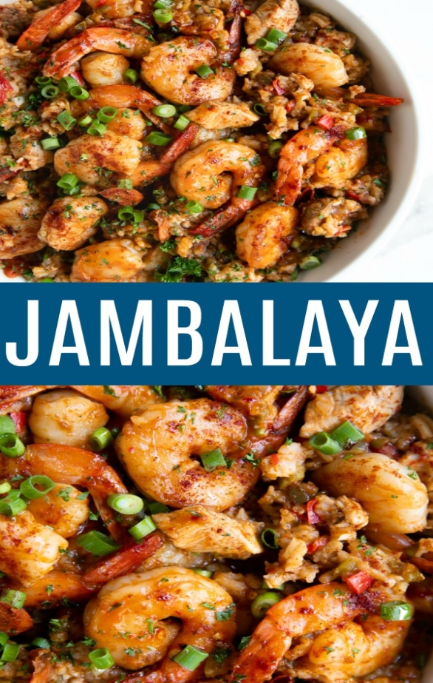
Jambalaya and a crawfish pie and file'gumbo 'Cause tonight I'm gonna see my ma cher amio
Pick guitar, fill fruit jar and be gay-o
Son of a gun, we'll have big fun on the bayou

Thibodeaux, Fontainenot, the place is buzzin'
Kinfolk come to see Yvonne by the dozen
Dress in style and go hog wild, me oh my oh
Son of a gun, we'll have big fun on the bayou

Chorus

I Settle down, far from town, get me a pirogue
And I'll catch all the fish in the bayou
Swap my mon to buy Yvonne what she need-o
Son of a gun, we'll have big fun on the bayou
Chorus
Son of a gun, we'll have big fun on the bayou

