NICE CUP OF TEA (Gina and Les)

1. Some folks put much reliance on politics and science,
There’s only one hero for me,
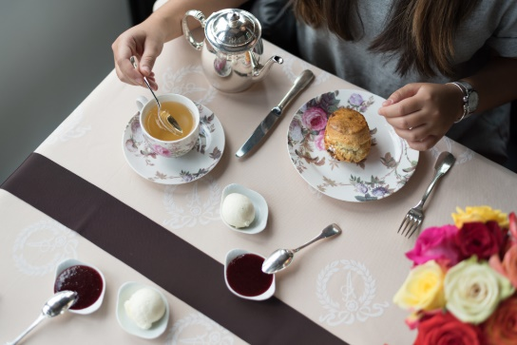
His praise we should be roaring,
The man how thought of pouring,
The first boiling water on to tea.

CHORUS

I like a nice cup of tea in the morning,
For to start the day you see
And at half-past eleven well my idea of heaven
Is a nice cup of tea.

I like a nice cup of tea with my dinner,
And a nice cup of tea with my tea
And when it’s time for bed
There’s a lot to be said for a nice cup of tea.

2. You can talk about your science and your airships in the sky,
I can go without the wireless and you’ll never see me fly,
The public benefactor of the universe for me
Is the genius who thought of pouring water on to tea.

3. They say it’s not nutritious but still it is delicious,
And that’s all that matters to me, it turns your meat to leather,
But let’s all die together, the one drink in paradise is tea.

CHORUS

4. You can talk about your liberties they talk of women’ rights
I don’t want to make no speeches, cos the one that does is trite,
And anyone can have my vote and chuck it in the sea,
But by golly they’ll be trouble if they try to touch my tea.

CHORUS

