Fly me to the moon

Fly me to the moon, and let me play among the stars
Let me see what spring is like on Jupiter and Mars
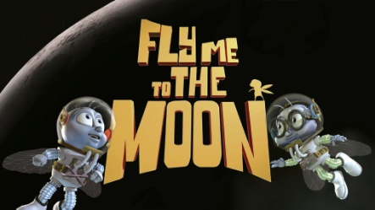
In other words, hold my hand. In other words, baby kiss me.

Fill my heart with song, and let me sing forever more
You're all that I long for, all I worship and do a-dore.
In other words, please be true! In other words, I love you!

Fill my heart with song, and let me sing forever more
You are all I long for, all I worship and do a-dore.
In other words, please be true! In other words, I love you!

Fill my heart with song, and let me sing forever more
You're all that I long for, all I worship and do a-dore.
In other words, please be true! In other words, in other words,…….. I love ..... you!

