High Hopes
Intro: Next time you're found with your chin on the ground, there’s a lot to be learned
So look around !

Verse 1: Just what makes that little old ant think he'll move that rubber tree plant
Anyone knows an ant can't move a rubber tree plant

Chorus:
But he's got high hopes, he's got high hopes, he's got high apple pie, in the sky hopes
So any time you're gettin' low 'stead of lettin' go, just remember that ant
Oops there goes another rubber tree plant!

When troubles call, and your back's to the wall, there’s a lot to be learned …
That wall could fall!

Verse 2: Once there was a silly old ram Thought he'd punch a hole in a dam
No one could make that ram, scram he kept buttin' that dam

Chorus:
Cause he had high hopes, he had high hopes, he had high apple pie, in the sky hopes
So any time you're feelin' bad 'stead of feelin' sad, just remember that ram
Oops there goes a billion kilowatt dam
/ctd over!
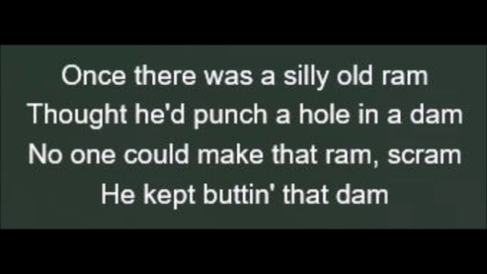
Instrumental Verse

Chorus:
All prob-lems just a toy balloon
They'll be bursted soon
They're just bound to go pop
Oops there goes another problem ker-plop, ker-plop!

