Let it be me

Verse 1:
I bless the day I found you
I want to stay around you
And so I beg you, let it be me
Don't take this heaven from one
If you must cling to someone
Now and forever, let it be me

Bridge:
Each time we meet love, I find complete love
Without your sweet love, what would life be?

So never leave me lonely, tell me you love me only
And that you'll always, let it be me

Instrumental verse

Repeat Bridge

Verse 4 x2:
So never leave me lonely, tell me you love me only
And that you'll always, let it be me
So never leave me lonely, tell me you love me only
And that you'll always, let it be me

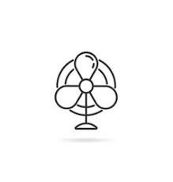
And that you'll always let it be me

