The ugly bug ball. (Intro :- Inchworm)

Once a lonely caterpillar sat and cried, to a sympathetic beetle by his side,
I’ve got nobody to hug; I’m such an ugly bug.
Then a spider and a dragonfly replied, if you’re serious and want to win a bride
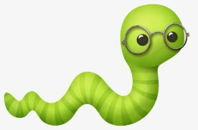
Come along with us, to the glorious annual ugly bug ball.

CHORUS:
Come on let’s crawl, gotta crawl, gotta crawl,
To the ugly bug ball, to the ball, to the ball,
And a happy time we’ll have there, one and all, at the ugly bug ball.
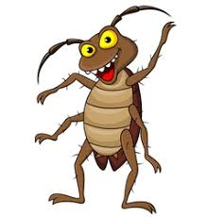
While the crickets clicked their cricky melodies,
All the ants were fancy dancing with the fleas,
Then up from under the ground, the worms came squirming around.
Oh they danced until their legs were nearly lame,
Every little crawling creature you could name,
Everyone was glad, what a time they had, they were so happy they came REPEAT CHORUS

Then our caterpillar saw a pretty queen
She was beautiful and yellow, black and green,
He said would you care to dance, their dancing led to romance,
Then she sat upon his caterpillar knee and he gave his caterpillar queen a squeeze.
Soon they’ll honeymoon, build a big cocoon, thanks to the ugly bug ball.
REPEAT CHORUS x 2 to end

